1. Our implementation trained on MNIST:

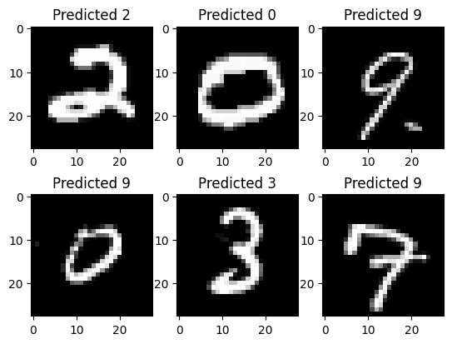

Validation Accuracy: 94%

1. Pretrained Model – ViT_B_32

On CIFAR dataset. - 0.96710527 test accurary